**Iteration 4 Report**

**Customer Meeting**

Date: 11/20

Time: 19:00 - 20:30

Place: HRBB 104

**Meeting Video**

<https://drive.google.com/open?id=1SWSz8qo3D2ugAtWF1Lc7U53zo26tbuKe>

**User Stories**

* As an administrator, I would like to see the information of on duty car in the main page, so that I can monitor their behavior.
* As a TAMUber backend engineer, I need an algorithm to decide which is the best car and driver to be dispatched, so that I can have answer the user's request.
* As an administrator, I would like to see the position of on duty car on google map, so that I can monitor their behavior.
* As an administrator, I would like to see the driving routes of the start point to the end point, so that I can see whether the cars are in the right position.
* As an administrator, I would like to see alert information if driver sent alert information to the system, so that I would know they need help.
* As an administrator, I would like to see the information of the car when I move mouse cursor to the car in monitor page, so that I can quickly get the information of that car.
* As an administrator, I would like to see the color of the car turn red on monitor page when the car send alert information to system, so that I would know they need help.

**Design Diagram**

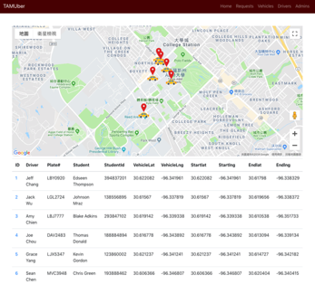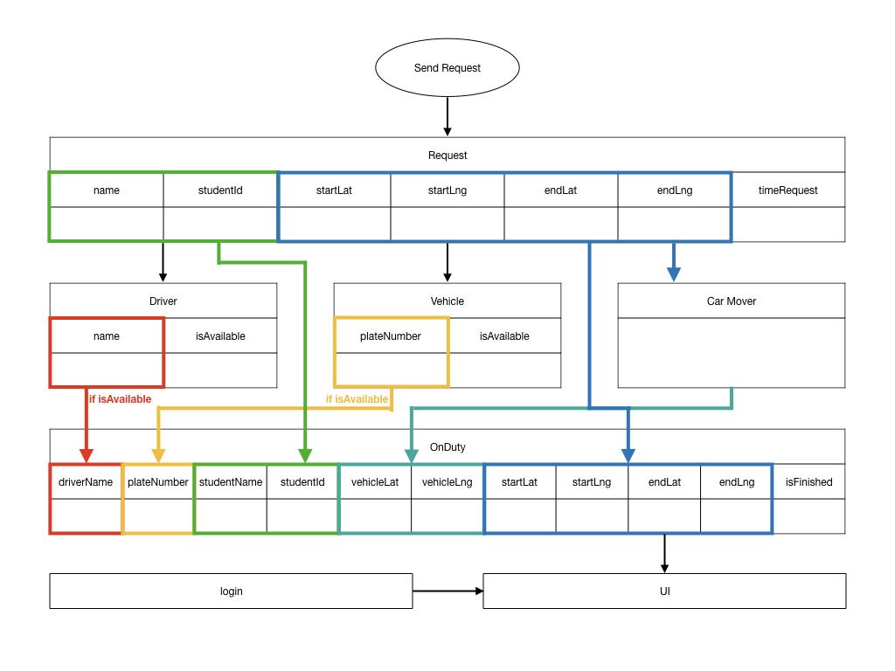

**Evaluations of Code and Tests**

rspec:

* rspec ./spec/controllers/driver_spec.rb

DEPRECATION WARNING: [Devise] including `Devise::TestHelpers` is deprecated and will be removed from Devise.

For controller tests, please include `Devise::Test::ControllerHelpers` instead.

(called from <top (required)> at /Users/yangchuya/Documents/tamu/software_engineering/TAMUber/spec/controllers/driver_spec.rb:3)

............

Finished in 0.17516 seconds (files took 3.53 seconds to load)

12 examples, 0 failures

Coverage report generated for RSpec to /Users/yangchuya/Documents/tamu/software_engineering/TAMUber/coverage. 38 / 145 LOC (26.21%) covered.

* rspec ./spec/controllers/user_spec.rb

DEPRECATION WARNING: [Devise] including `Devise::TestHelpers` is deprecated and will be removed from Devise.

For controller tests, please include `Devise::Test::ControllerHelpers` instead.

(called from <top (required)> at /Users/yangchuya/Documents/tamu/software_engineering/TAMUber/spec/controllers/user_spec.rb:3)

.

Finished in 0.03722 seconds (files took 1.5 seconds to load)

1 example, 0 failures

Coverage report generated for RSpec to /Users/yangchuya/Documents/tamu/software_engineering/TAMUber/coverage. 16 / 154 LOC (10.39%) covered.

* rspec ./spec/controllers/vehicles_controller_spec.rb

DEPRECATION WARNING: [Devise] including `Devise::TestHelpers` is deprecated and will be removed from Devise.

For controller tests, please include `Devise::Test::ControllerHelpers` instead.

(called from <top (required)> at /Users/yangchuya/Documents/tamu/software_engineering/TAMUber/spec/controllers/vehicles_controller_spec.rb:4)

...........

Deprecation Warnings:

Using `should` from rspec-expectations' old `:should` syntax without explicitly enabling the syntax is deprecated. Use the new `:expect` syntax or explicitly enable `:should` with `config.expect_with(:rspec) { |c| c.syntax = :should }` instead. Called from /Users/yangchuya/Documents/tamu/software_engineering/TAMUber/spec/controllers/vehicles_controller_spec.rb:80:in `block (4 levels) in <top (required)>'.

If you need more of the backtrace for any of these deprecations to

identify where to make the necessary changes, you can configure

`config.raise_errors_for_deprecations!`, and it will turn the

deprecation warnings into errors, giving you the full backtrace.

1 deprecation warning total

Finished in 0.1623 seconds (files took 1.52 seconds to load)

11 examples, 0 failures

Coverage report generated for RSpec to /Users/yangchuya/Documents/tamu/software_engineering/TAMUber/coverage. 37 / 145 LOC (25.52%) covered.

**Pivotal Tracker**

<https://www.pivotaltracker.com/n/projects/2205674>

**Github Repo**

<https://github.com/ShaoEnChen/TAMUber>

**Heroku**

<https://tamu-uber.herokuapp.com/>